
Faculty of Computer Science and Mathematics

Lab Exercise 3

Name: | Nur Aqilah Syahirah Binti Ahmad Tajuddin
Matric Num: | S80850



Overview:

This in-class exercise extends Lab Exercise 3. You will apply block and inline elements,
<div> for page organization, HTML entities, HTML5 input types and attributes (placeholder, autofocus, required), <datalist> and the <output> element to solve a realistic problem.
There are two problems. Your lecturer will assign one problem to you, or you may be asked to complete both.

Learning Outcomes
- Differentiate and correctly use block and inline elements.
- Organize a web page into sections using <div> elements.
- Apply HTML entities to display reserved and special characters.
- Implement HTML5 input types, input attributes and <datalist> in a form.
- Use the <output> element to display a calculated result dynamically.

Best of luck!

Problem A: Campus Bakery Online Order Page
A small bakery on campus wants customers to place pre-orders online. Customers must be able to see the price list, fill in an order form, and see the total price instantly before submitting the order. Build the page using HTML only (no CSS). You may choose any bakery name, products and prices.

Instructions
Create a file named lab3_ExerA.html that contains the following:

Page Structure
  - Use <!DOCTYPE html> and organize the whole page using five <div> elements with the ids header, nav, content, sidebar and footer.

Header and Navigation
  - In the header, display the bakery name using <h1>, and use a <span> inside the <h1>
for a short slogan.
  - In the nav, create at least three inline links (<a>) separated by “ | ”.

Block and Inline Elements
  - In the content section, write an introduction paragraph (<p>) that contains at least three different inline elements, e.g. <strong>, <em>, <span> and <a>.
  - Use at least three different block elements in the page (e.g. <h2>, <p>, <ul>, <div>).

HTML Entities (Sidebar and Footer)
  - In the sidebar, show a “Price List” using a list. Use at least four different entities in the page, for example:
    - &reg; for the brand name (e.g. CampusBake®)
    - &lt; or &gt; (e.g. Orders > 10 pieces get a free drink)
    - &nbsp;, &pound; or &euro;, and &copy; in the footer

Order Form (HTML5 Form Elements)
Inside a <div> in the content section, create an order form that contains:
  - Customer name: text input with placeholder, required and autofocus.
  - Phone number (type="tel") and e-mail (type="email"), both required.
  - Pick-up date (type="date") and pick-up time (type="time").
  - Flavour: an input linked to a <datalist> with at least 4 flavours.
  - Icing colour (type="color") and sweetness level using a range slider (min="1", max="5", step="1").
  - A submit button.

- Price Calculator (<output>)
  - Add two number inputs: Cupcakes (RM 3.00 each) and Cake Slices (RM 5.00 each), each with min="0" and value="0".
  - Use the form oninput attribute and an <output> element (with the correct name and for attributes) to show the total price automatically, e.g. 2 cupcakes + 1 slice = 11.

Comments
  - Use comments (<!-- ... -->) to explain each section of your code.

Testing
  - Click Submit with all fields empty. What happens? Then enter “myemail” in the e-mail field and submit again. Write your observations as a comment at the end of your file.
  - Validate the file at https://validator.w3.org (Validate by File Upload).

Submission
Save the file as lab3_ExerA.html, validate it at https://validator.w3.org (Validate by File Upload), and submit it (Submit lab3_ExerA.html and Screenshot of validation) through Github > Update your index.html (if you hosting your lab in Github pages)

Problem A: Campus bakery Order Online Page (Codes and Output)

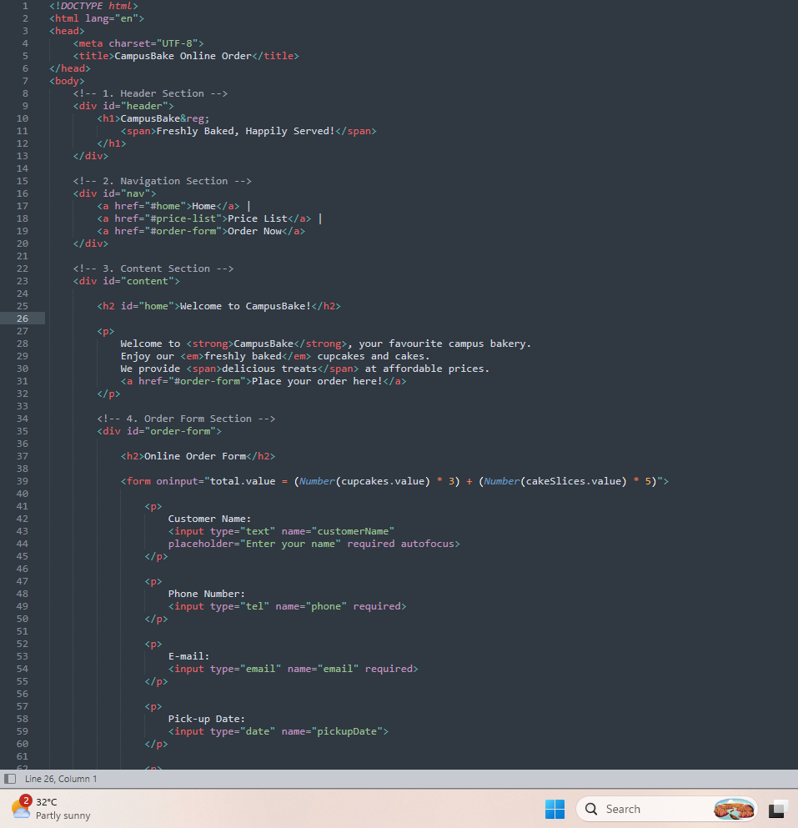
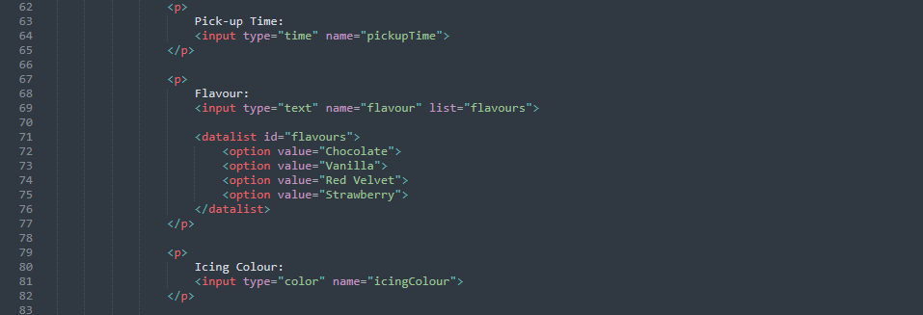

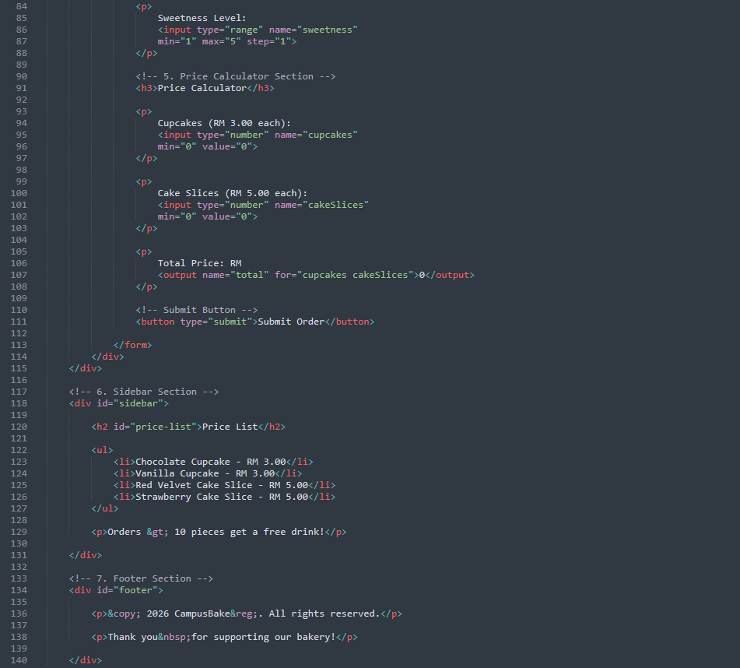

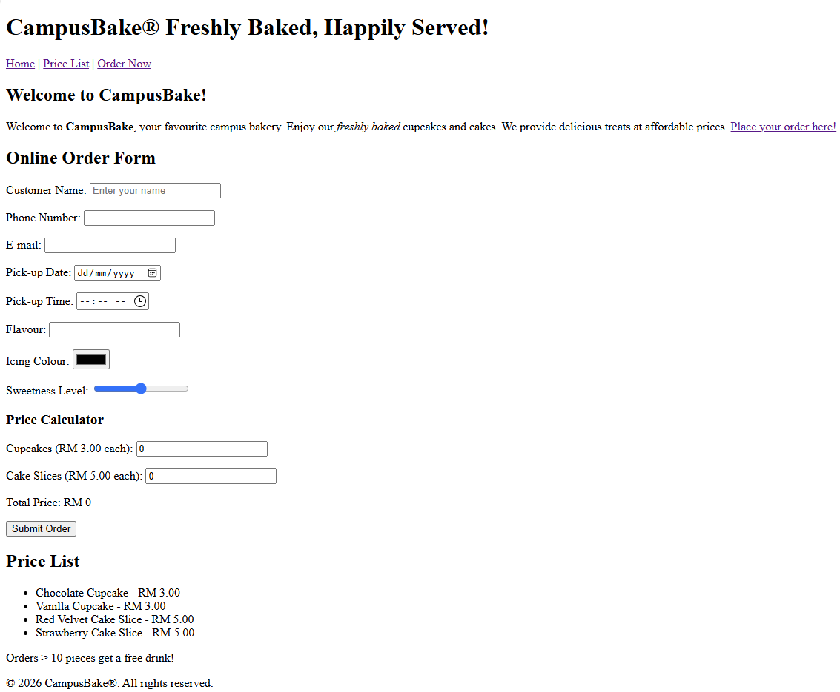
Output

Testing

Click Submit with all fields empty. What happens? Then enter “myemail” in the e-mail field and submit again. Write your observations as a comment at the end of your file.
When clicking Submit with all fields empty,
the browser prevents submission because required fields are empty. When entering "myemail" in the email field, the browser prevents submission because the email format is invalid.

Validate the file at https://validator.w3.org (Validate by File Upload).
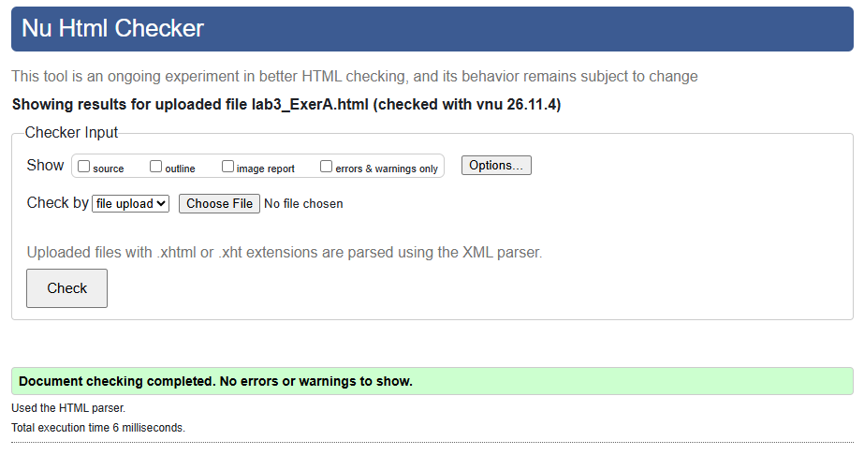

Problem B: Ticket Booking (Debugging and Extend)

The campus cinema club built a ticket booking page, but users have reported several problems: the e-mail field accepts anything, the movie suggestions do not appear, the slider behaves strangely and the total shows “23” when the user books 2 adult and 3 child tickets. The copyright symbol also does not display. Find and fix the errors, then extend the page.

Given Code

- <!DOCTYPE>
- <html lang="en">
- <head>
- <meta charset="utf-8">
- <title>Ticket Booking</title>
- </head>
- <body>
- <div id="header">
- <h1>e-Ticket <span>Your Campus Cinema</h1></span>
- </div>
- <span id="content">
- <h2>Book Your Ticket</h2>
- <p>Promotion: tickets < RM10 for students &amp staff!</p>
- <form action="booking.php" oninput="total.value = adult.value + child.value">
- <label for="name">Name:</label>
- <input type="text" id="name" name="name" placeholder="Enter your name" required autofocus><br>
- <label for="email">E-mail:</label>
- <input type="emial" id="email" name="email"><br>
- <label for="date">Show date:</label>
- <input type="date" id="date" name="date"><br>
- <label for="movie">Movie:</label>
- <input id="movie" name="movie" list="movies"><br>
- <datalist id="movielist">
- <option value="Space Rangers">
- <option value="Kampung Comedy">
- </datalist>
- <label for="adult">Adult tickets:</label>
- <input type="number" id="adult" name="adult" value="0"><br>
- <label for="child">Child tickets:</label>
- <input type="number" id="child" name="child" value="0"><br>
- <label for="rating">Rate our service:</label>
- <input type="range" id="rating" name="rating" min="5" max="1"><br>
- Total tickets: <output name="total" for="adult kid"></output><br>
- <input type="submit" value="Book Now">
- </form>
- </span>
- <div id="footer">
- <p>&Copy; 2026 CineKampus. All rights reserved.</p>
- </div>
- </body>
- </html>54 </body>
55 </html>

Instructions
Part 1. Find and Fix the Errors
- Copy the given code into a new file named lab3_ExerB.html.
- Identify and correct all errors. At the top of the <body>, write an HTML comment listing each error and the line number, e.g. <!-- Error 1 (Line 1): missing <!DOCTYPE html> -->.
- Test the page: the movie suggestions must appear, the e-mail field must reject “myemail”, and 2 adult + 3 child tickets must show a total of 5.
- Validate your corrected file at https://validator.w3.org. Your final page must show “No errors or warnings to show”.

Part 2. Extend into a Two-Page Website
- Add a <div id="sidebar"> titled “Now Showing” that lists at least 3 movies. Each item must use inline elements: the title in <strong>, the age rating in <span> and a trailer link using <a>.
- Add a phone number input (type="tel") with a placeholder and required, and a show time input (type="time").
- Add a second <output name="price"> that shows the total price, where an adult ticket is RM 12 and a child ticket is RM 8 (e.g. 2 adults + 3 children = 48).
- In the footer, add the text “e-Ticket® – Campus Cinema < RM10 every Tuesday” using the correct entities for ®, < and &.
- Use comments to explain each new section of your code.

Submission

Save the file as lab3_ExerB.html, validate it at https://validator.w3.org (Validate by File Upload), and submit it (Submit lab3_ExerB.html and Screenshot of validation) through Github.

Problem B: Ticket Booking Debugging and Extend (Codes and Output)

Error Identification
- Error 1 (Line 1): Incorrect DOCTYPE declaration. Changed to <!DOCTYPE html>.
- Error 2 (Line 9): Incorrect nesting of span and h1 tags. Corrected the order.
- Error 3 (Line 11): Used span for the main content. Changed to div.
- Error 4 (Line 13): Missing semicolon in &amp; entity.
- Error 5 (Line 14): Incorrect addition of adult and child values as strings. Used Number().
- Error 6 (Line 18): Incorrect input type "emial". Changed to "email" and added required.
- Error 7 (Line 22): Datalist ID did not match the input list attribute.
- Error 8 (Line 23): Incorrect datalist ID. Changed to "movies".
- Error 9 (Line 32): Range min and max values were reversed. Corrected to min="1" max="5".
- Error 10 (Line 33): Incorrect output for attribute. Changed to for="adult child".
- Error 11 (Line 38): Incorrect copyright entity &Copy;. Changed to &copy;.
- Error 12 (Lines 54-55): Duplicate closing body and html tags removed.

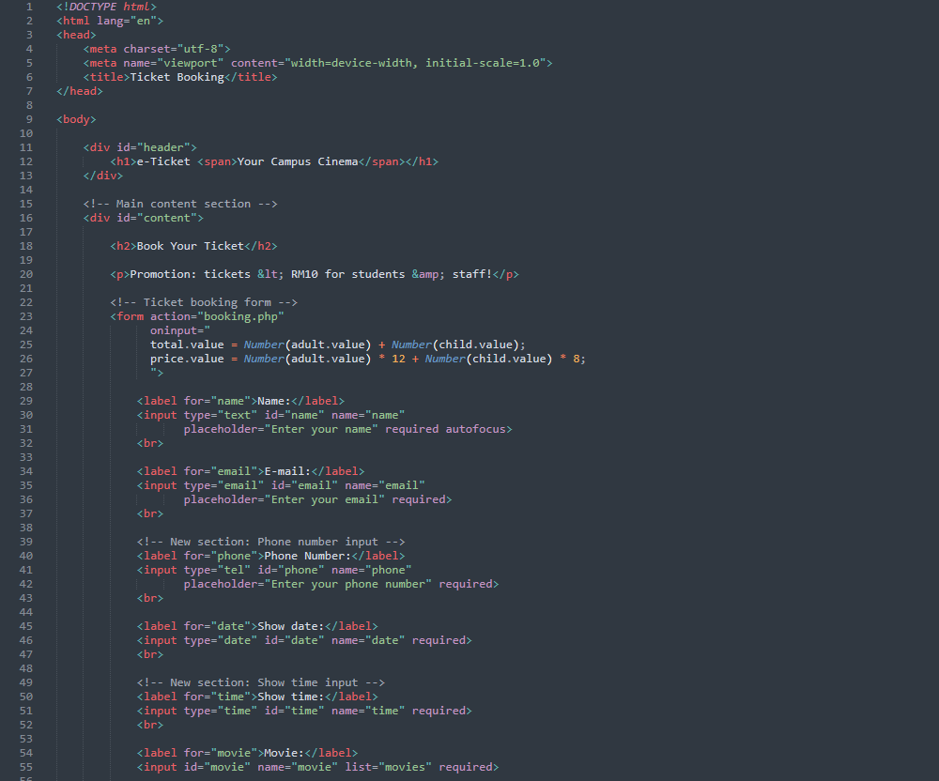

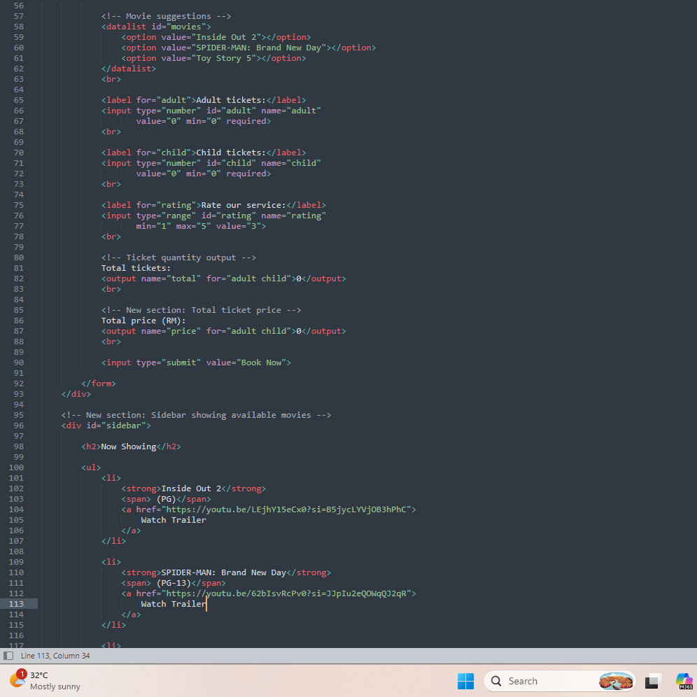
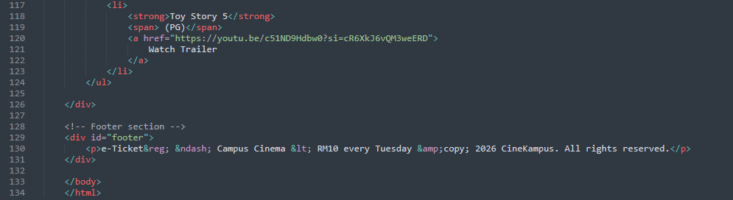

Validate
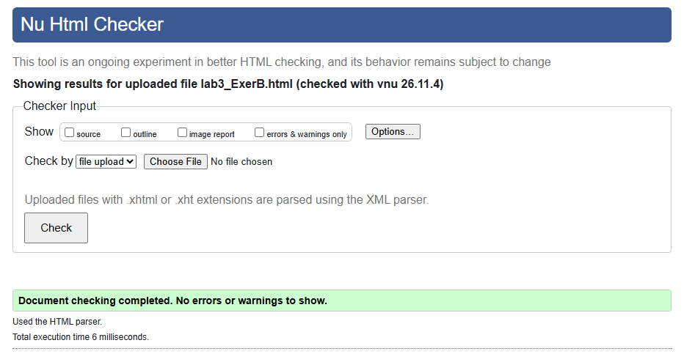

Output
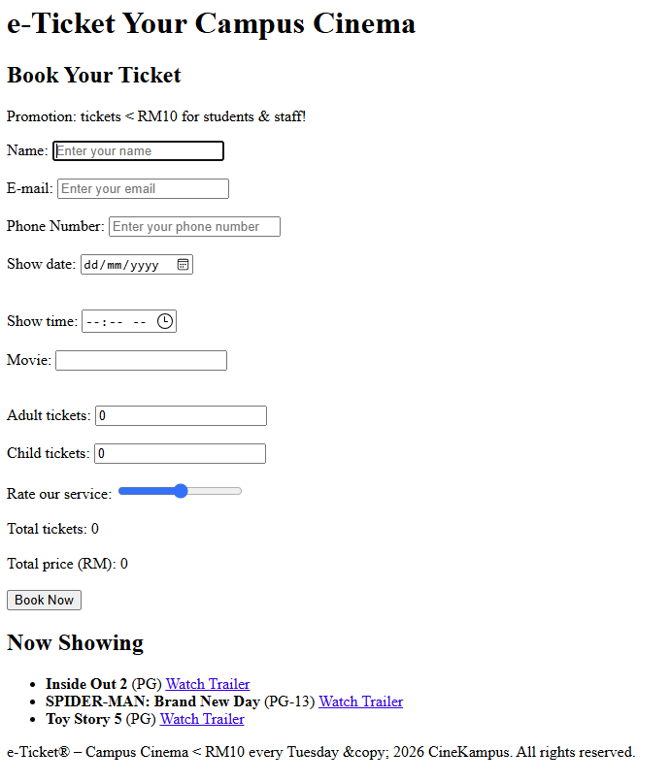

Rubric
Table A: Rubric for Additional Lab Exercise 3 – Problem A

Criteria | Excellent (5) | Good (4) | Average (2–3) | Needs Improvement (0–1)
Page Structure | Uses all five <div> sections (header, nav, content, sidebar, footer) with correct ids and logical organization. | Uses <div> sections effectively with minor layout or naming issues. | Uses some <div> elements but the structure lacks refinement or sections are missing. | Poor organization or does not use <div> elements appropriately.
Block and Inline Elements | Correctly uses <span> inside <h1>, inline links in nav, and at least 3 inline and 3 block elements with correct nesting. | Demonstrates block vs. inline elements with minor mistakes. | Attempts to use block and inline elements, but lacks clarity or nesting is incorrect. | Does not demonstrate understanding of block vs. inline elements.
HTML Entities | Correctly uses at least 4 different entities (incl. &copy; and &reg;) in appropriate locations. | Uses entities with minor errors (e.g. only 3 types). | Attempts to use entities but with noticeable mistakes (wrong case, missing semicolon). | Fails to include or misuses HTML entities.
HTML5 Form Elements | Includes tel, email, date, time, color, range and datalist, with placeholder, required and autofocus used correctly. | Includes most required inputs and attributes with minor issues. | Includes some HTML5 inputs but lacks variety or attributes. | Lacks required form elements or has significant errors.
Use of <output> Element | Total price is calculated correctly and updates dynamically; <output> has correct name and for. | Implements <output> with minor issues (e.g. wrong for attribute). | Attempts <output> but calculation is incorrect (e.g. joins numbers as text). | Fails to implement or incorrectly uses  <output>.
Total |  |  |  | 25 marks

Table B: Rubric for Additional Lab Exercise 2 – Problem B

Criteria | Excellent (5) | Good (4) | Average (2–3) | Needs Improvement (0–1)
Error Identification | Identifies at least 8 errors correctly with line numbers and clear explanations. | Identifies 6–7 errors correctly. | Identifies 3–5 errors, or explanations are unclear. | Identifies fewer than 3 errors.

Criteria | Excellent (5) | Good (4) | Average (2–3) | Needs Improvement (0–1)
Error Correction & Validation | All errors corrected; page works as described and passes the W3C Validator with no errors. | Most errors corrected with 1–2 remaining validation errors. | Some errors corrected but the page still does not work correctly. | Few or no errors corrected.
Page Structure and Block/Inline Elements | Sidebar <div> added with at least 3 movies using <strong>, <span> and <a> correctly; content uses <div> correctly. | Sidebar added with minor nesting or layout issues. | Sidebar attempted but inline elements are missing or misused. | Sidebar not added or block/inline elements misused.
HTML5 Form Elements and Entities | tel (with placeholder and required) and time inputs added; footer uses &reg;, &lt; and &amp; correctly. | Inputs and entities added with minor errors. | Some inputs or entities added with noticeable mistakes. | Inputs and entities not added or incorrect.
Use of <output> Element | Both outputs (total tickets and total price) calculate correctly and update dynamically. | Outputs work with minor issues. | Output attempted but calculation is incorrect. | Fails to implement the price output.
Total |  |  |  | 25 marks

